SUDENT’S HANDOUT MVC EXERCISE1
Welcome to the MVC in ASP.NET Core training session on creating a job portal application! This handout provides guidelines for students on how to approach the material, participate in workshops, and complete exercises. This Topic Includes Creating View ,Controller ,Dependency Injections and other functionalities..
Create a Company controller to perform Company Registrations,Company Profile,Company Member Registration,Company Member Listing,Remove Company Member

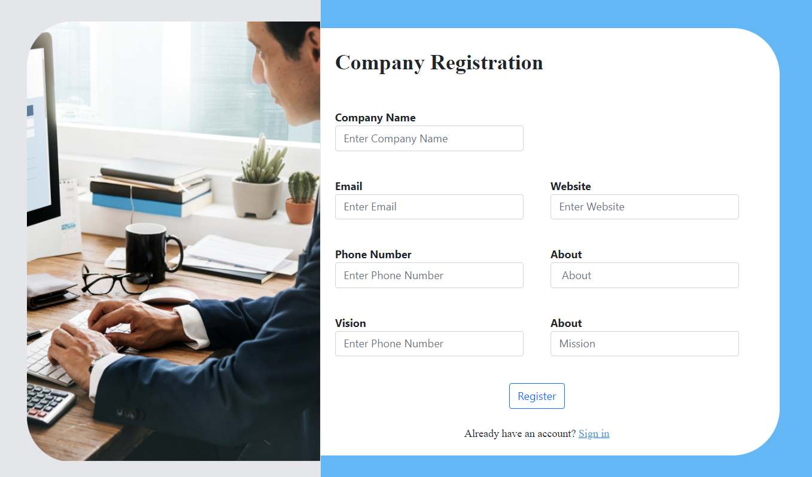

Company Profile:
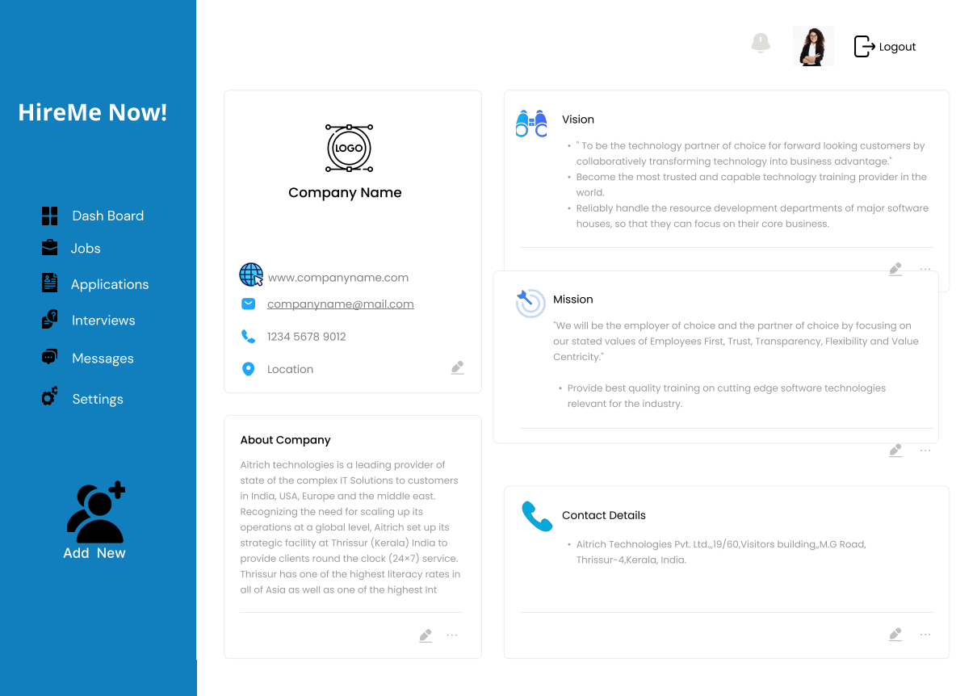

Company Member Register
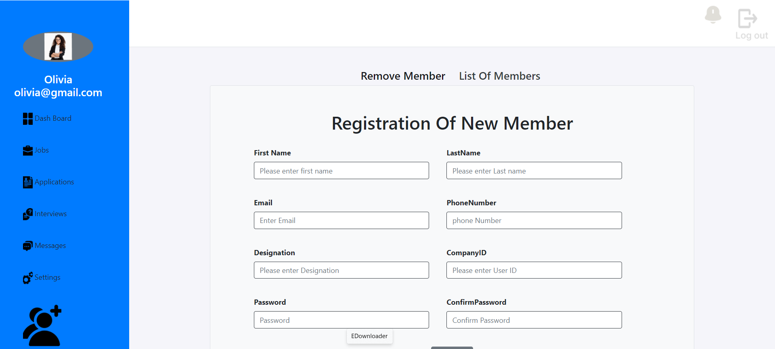

Remove Company Member
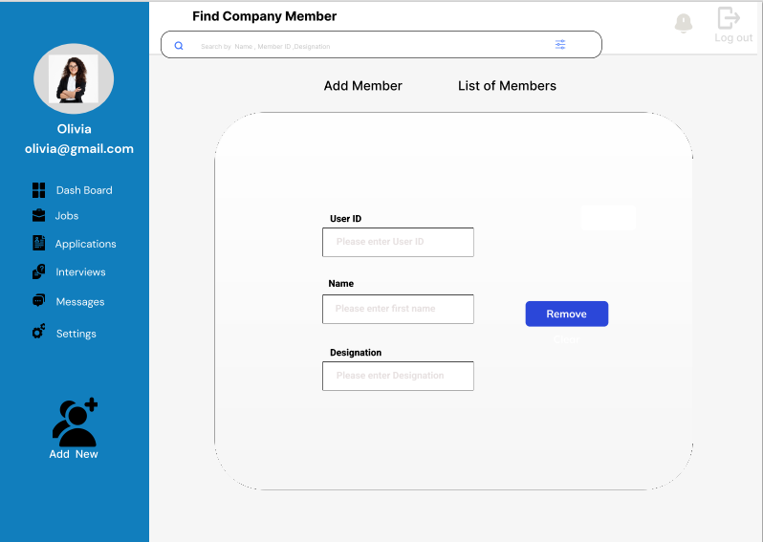

Company Member Listing
